PTMT Alive

**Extro Plastic Bib Cock – Yellow & White Body**

**Product Description**

The **Plastic Bib Cock with Yellow Handle** is an economical and corrosion-free tap designed for everyday water flow control in outdoor and indoor utility spaces. Made from high-grade plastic, it is lightweight, easy to maintain, and ideal for low-pressure applications like gardens, wash areas, and terraces.

**Key Features *(in single-line format)***

✅ Rust-proof plastic material ideal for long-term use  
✅ Smooth and easy quarter-turn operation  
✅ Bright yellow design adds a fresh visual touch  
✅ Lightweight and easy to install anywhere  
✅ Suitable for outdoor taps, gardens, and utility areas

**Product Specifications**

* **Product Type:** Plastic Bib Cock
* **Material:** Durable Plastic (ABS/PP)
* **Color:** Yellow Handle with White Body
* **Finish:** Glossy/Matte (varies by model)
* **Operation:** Quarter-turn mechanism
* **Mount Type:** Wall Mounted
* **Handle Type:** Lever Style
* **Connection Size:** 15 mm (½ inch BSP)
* **Application:** Outdoor, garden, washing area, utility
* **Warranty:** As per manufacturer's standard (typically 1 year)

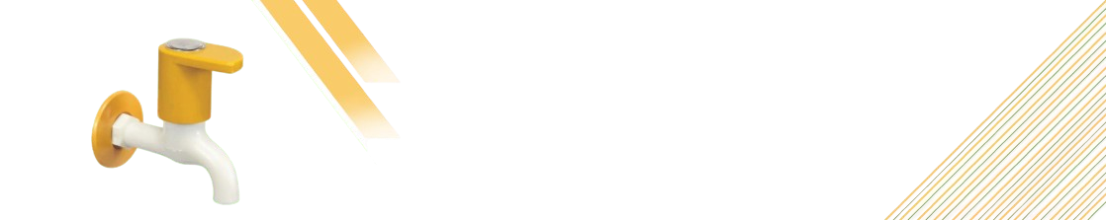

**Extro Plastic Bib Cock – Yellow & White (Wall Mounted)**

**Product Description**

The **Yellow & White Plastic Bib Cock** is a stylish, durable, and cost-effective solution for everyday water control. Perfect for outdoor, garden, and utility use, this bib cock is crafted from high-quality plastic to resist rust and chemical corrosion, ensuring lasting performance even in harsh weather conditions.

**5 Key Features (in single line)**

✅ High-quality rust-free plastic for durability  
✅ Bright yellow handle with modern aesthetics  
✅ Easy quarter-turn operation for smooth flow  
✅ Lightweight, easy to install and maintain  
✅ Ideal for gardens, terraces, and utility areas

**Product Specifications**

* **Product Type:** Plastic Bib Cock
* **Material:** Sturdy Plastic (ABS/Polypropylene)
* **Color:** Yellow Handle & White Body
* **Finish:** Smooth Glossy Finish
* **Mounting Type:** Wall Mounted
* **Handle Operation:** Quarter-turn mechanism
* **Connection Size:** 15 mm (½ inch BSP thread)
* **Application:** Garden, outdoor, wash area, utility use
* **Warranty:** 1 year standard (may vary by manufacturer)



**Extro Plastic Bib Cock – Yellow & White (Wall Mounted)**

**Product Description**

The **Yellow & White Plastic Bib Cock** is a stylish, durable, and cost-effective solution for everyday water control. Perfect for outdoor, garden, and utility use, this bib cock is crafted from high-quality plastic to resist rust and chemical corrosion, ensuring lasting performance even in harsh weather conditions.

**5 Key Features (in single line)**

✅ High-quality rust-free plastic for durability  
✅ Bright yellow handle with modern aesthetics  
✅ Easy quarter-turn operation for smooth flow  
✅ Lightweight, easy to install and maintain  
✅ Ideal for gardens, terraces, and utility areas

**Product Specifications**

* **Product Type:** Plastic Bib Cock
* **Material:** Sturdy Plastic (ABS/Polypropylene)
* **Color:** Yellow Handle & White Body
* **Finish:** Smooth Glossy Finish
* **Mounting Type:** Wall Mounted
* **Handle Operation:** Quarter-turn mechanism
* **Connection Size:** 15 mm (½ inch BSP thread)
* **Application:** Garden, outdoor, wash area, utility use
* **Warranty:** 1 year standard (may vary by manufacturer)

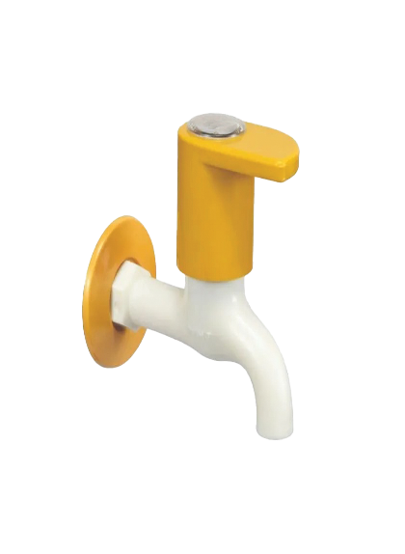

**Extro Plastic Bib Cock – Yellow Top with White Body (Wall Mounted)**

**Product Description**

This **Plastic Bib Cock** features a stylish yellow top with a white body, designed for robust performance in utility areas. Ideal for outdoor, garden, or terrace use, it combines a sleek appearance with functional ease, resisting rust and weather wear over time.

**5 Key Features (in single line)**

✅ Stylish dual-tone design enhances appearance  
✅ Rustproof plastic ideal for outdoor conditions  
✅ Smooth quarter-turn lever for easy use  
✅ Lightweight and quick to install  
✅ Suitable for low-pressure water applications

**Product Specifications**

* **Product Type:** Wall Mounted Plastic Bib Cock
* **Material:** High-grade Plastic (ABS or equivalent)
* **Color:** Yellow Top, White Body
* **Finish:** Smooth Gloss
* **Installation Type:** Wall Mount
* **Handle Operation:** Quarter-turn handle
* **Connection Size:** 15 mm (½ inch BSP)
* **Usage:** Garden, wash area, balcony, or terrace taps
* **Warranty:** 1 year (may vary by manufacturer)

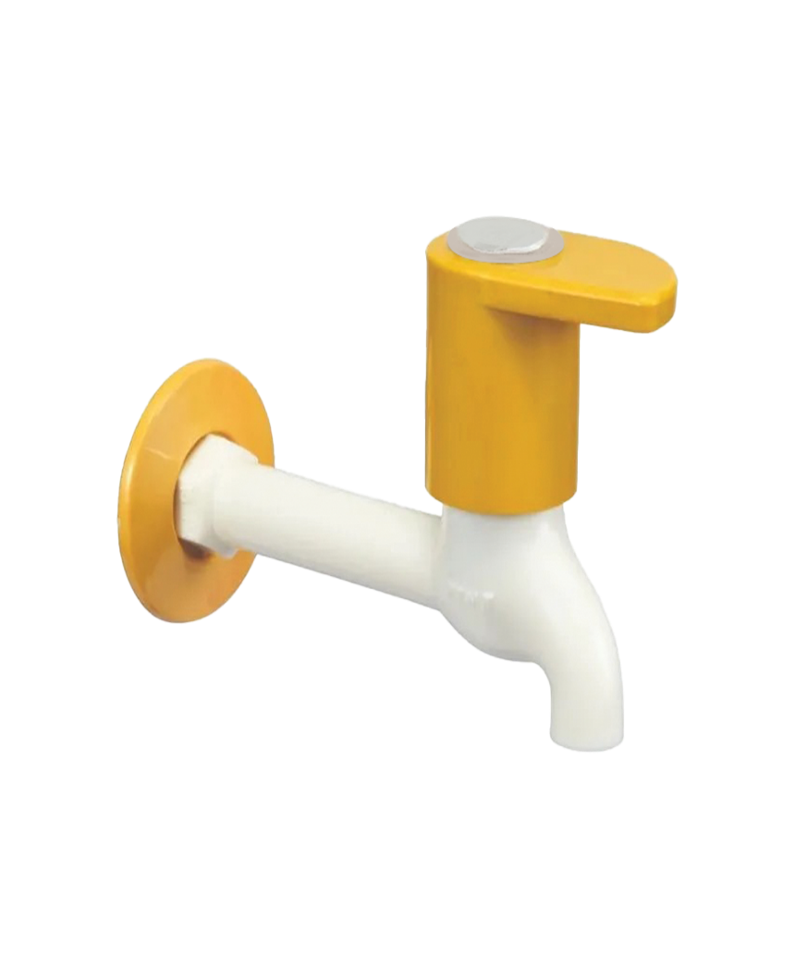

**Extro Plastic Angular Stop Cock – Yellow & White (Wall Mounted)**

**Product Description**

The **Plastic Angular Stop Cock** offers a compact and contemporary solution for regulating water flow to geysers, flush tanks, or washing machines. Its vibrant yellow-white dual-tone design adds modern appeal while its durable plastic body ensures rust-free longevity.

**5 Key Features (in single line)**

✅ Compact 90° design ideal for tight corners  
✅ Rust-free ABS plastic construction  
✅ Smooth handle operation with minimal effort  
✅ Easy installation with wall flange  
✅ Ideal for appliances like geysers and flush tanks

**Product Specifications**

* **Product Type:** Plastic Angular Stop Cock
* **Material:** High-quality ABS Plastic
* **Color:** Yellow & White
* **Finish:** Glossy
* **Mount Type:** Wall Mounted
* **Inlet Size:** 15 mm (½ inch BSP)
* **Outlet Type:** Male threaded outlet
* **Handle Type:** Turn knob with easy grip
* **Application:** Geysers, flushing systems, washing machine inlet
* **Warranty:** 1 year (may vary by manufacturer)

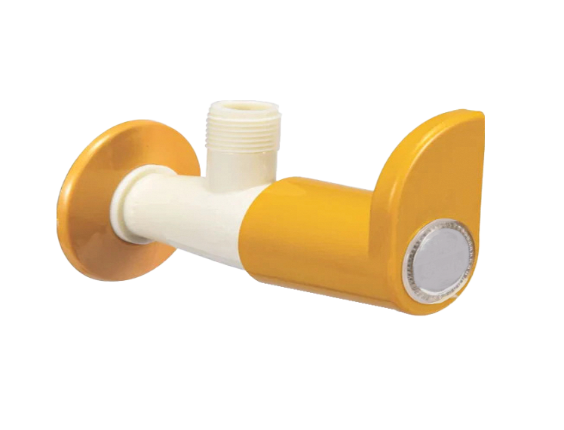

**Plastic 2-Way Angle Cock – Dual Control (Yellow & White)**

**Product Description**

The **Plastic 2-Way Angle Cock** offers the convenience of controlling two water outlets from a single wall point, making it ideal for bathrooms or utility areas. Its dual-handle mechanism and durable plastic body provide efficiency with a modern yellow & white aesthetic.

**5 Key Features (in single line)**

✅ Dual outlet design for two-point water control  
✅ Strong ABS plastic for rust-proof durability  
✅ Smooth-turn handles for effortless operation  
✅ Easy wall-mounted installation with flange  
✅ Ideal for bathrooms, washing areas, and kitchen utilities

**Product Specifications**

* **Product Type:** 2-Way Angle Cock
* **Brand:** Extro
* **Material:** ABS Plastic
* **Color:** Yellow & White
* **Mount Type:** Wall Mounted
* **Inlet Size:** 15 mm (½ inch BSP)
* **Outlet Type:** Twin male threaded outlets
* **Control Type:** Dual knobs for separate flows
* **Application:** Bathroom, washing machine, hand shower, utility taps
* **Finish:** Glossy
* **Warranty:** 1 year (may vary by supplier)

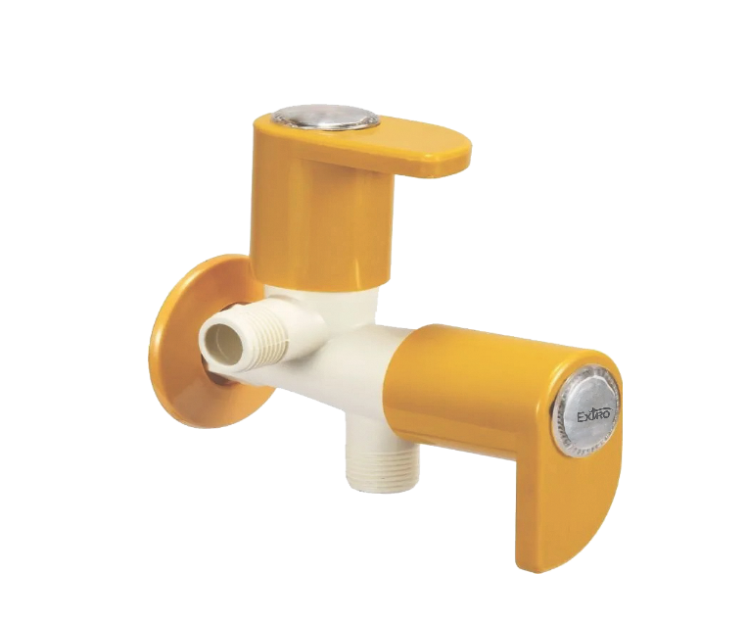

**Extro Plastic 2-Way Bib Cock with Nozzle (Yellow & White)**

**Product Description**

The **Extro Plastic 2-Way Bib Cock** is a dual-function water tap crafted for homes that need both a regular tap and an attachment for appliances like washing machines or garden hoses. Designed with an ergonomic yellow-and-white body, it brings utility and style together.

**5 Key Features (single-line)**

✅ Dual water outlet with side nozzle for appliances  
✅ Rust-free ABS body ensures long-term durability  
✅ Sleek modern handle design for smooth control  
✅ Easy installation with wall flange support  
✅ Ideal for bathrooms, utility zones, and outdoor use

**Product Specifications**

* **Brand:** Extro
* **Model:** 2-Way Bib Cock with Nozzle
* **Material:** High-grade ABS Plastic
* **Color:** Yellow and White
* **Mounting Type:** Wall Mounted
* **Inlet Size:** 15mm (½ inch BSP)
* **Control Type:** Dual handle
* **Outlet Type:** Front spout + Side male threaded nozzle
* **Use Case:** Washing machine, garden hose, bathroom
* **Finish:** Glossy smooth surface
* **Durability:** UV-resistant, corrosion-proof
* **Warranty:** 1 year (manufacturer dependent)

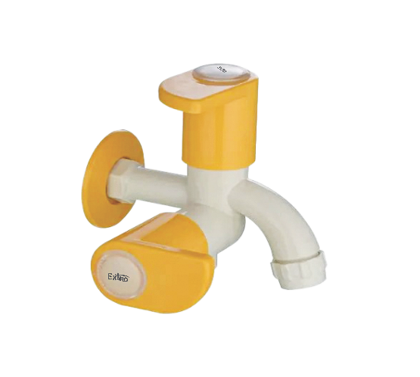

**Extro Plastic Swan Neck Tap (Yellow & White)**

**📝 Product Description:**

The Extro Plastic Swan Neck Tap is a stylish, functional faucet ideal for kitchen sinks and utility areas. Featuring a high-arched spout and vibrant yellow-and-white design, it offers a smooth water flow and modern aesthetic for everyday use.

**✅ Key Features (Single Line):**

* High-arched swan neck design for better reach and clearance
* Durable ABS plastic body with corrosion-resistant finish
* Ergonomic lever handle for smooth water control
* Easy to install with standard wall flange
* Suitable for kitchens, utility areas, and washbasins

**Product Specifications:**

* **Brand:** Extro
* **Model:** Plastic Swan Neck Tap
* **Material:** High-grade ABS Plastic
* **Color:** Yellow and White
* **Mounting Type:** Wall Mounted
* **Inlet Size:** 15mm (½ inch BSP)
* **Handle Type:** Single lever
* **Spout Type:** Fixed Swan Neck
* **Finish:** Glossy smooth surface
* **Use Case:** Kitchen, utility sink, basin
* **Durability:** Rust-proof, lightweight, and UV-resistant
* **Warranty:** 1 year (as per manufacturer policy)

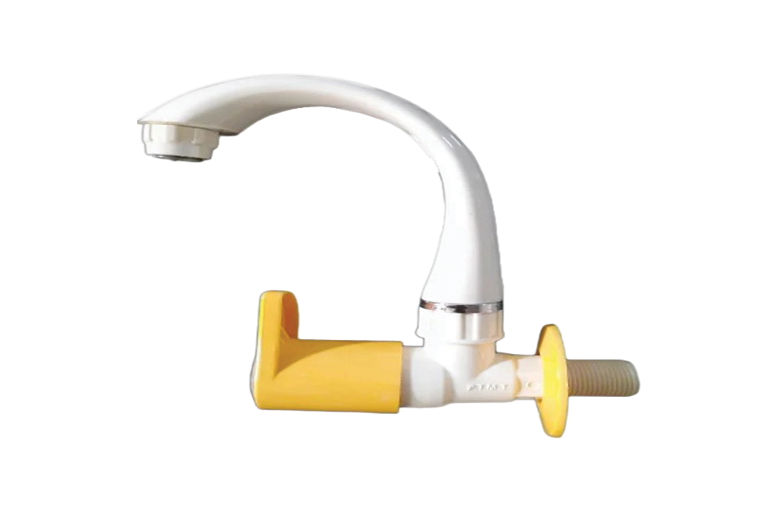

**Extro Plastic Centre Control Swan Neck Tap (Yellow & White)**

**📝 Product Description:**

The Extro Plastic Centre Control Swan Neck Tap is designed for style and efficiency in kitchens and washbasins. With its distinct yellow handle and central rotating knob, this tap ensures a smooth flow and ease of use for daily utility needs.

**✅ Key Features :**

* Central rotating knob for effortless water control
* Stylish swan neck design for maximum reach and clearance
* High-quality ABS plastic ensures rust-free performance
* Bright yellow ergonomic handle enhances modern aesthetics
* Quick and easy installation with standard fittings

**📐 Product Specifications:**

* **Brand:** Extro
* **Model:** Centre Control Swan Neck Tap
* **Material:** ABS Plastic
* **Color:** Yellow and White
* **Mounting Type:** Counter/Deck Mounted
* **Inlet Size:** 15mm (½ inch BSP)
* **Handle Type:** Central rotary knob
* **Spout Type:** Fixed Swan Neck
* **Finish:** Glossy and smooth
* **Use Case:** Kitchen sink, washbasin, utility areas
* **Durability:** UV-resistant, corrosion-proof
* **Warranty:** 1 year (manufacturer dependent)

